Comprehensive Comparison

Accuracy for Fisher’s Linear Discriminant=99.98%

Accuracy for Linear Perceptron=99.99%

Accuracy for Naïve Bayes=99.098%

Accuracy for Neural network=99.98%

Accuracy for SVM=99.99%

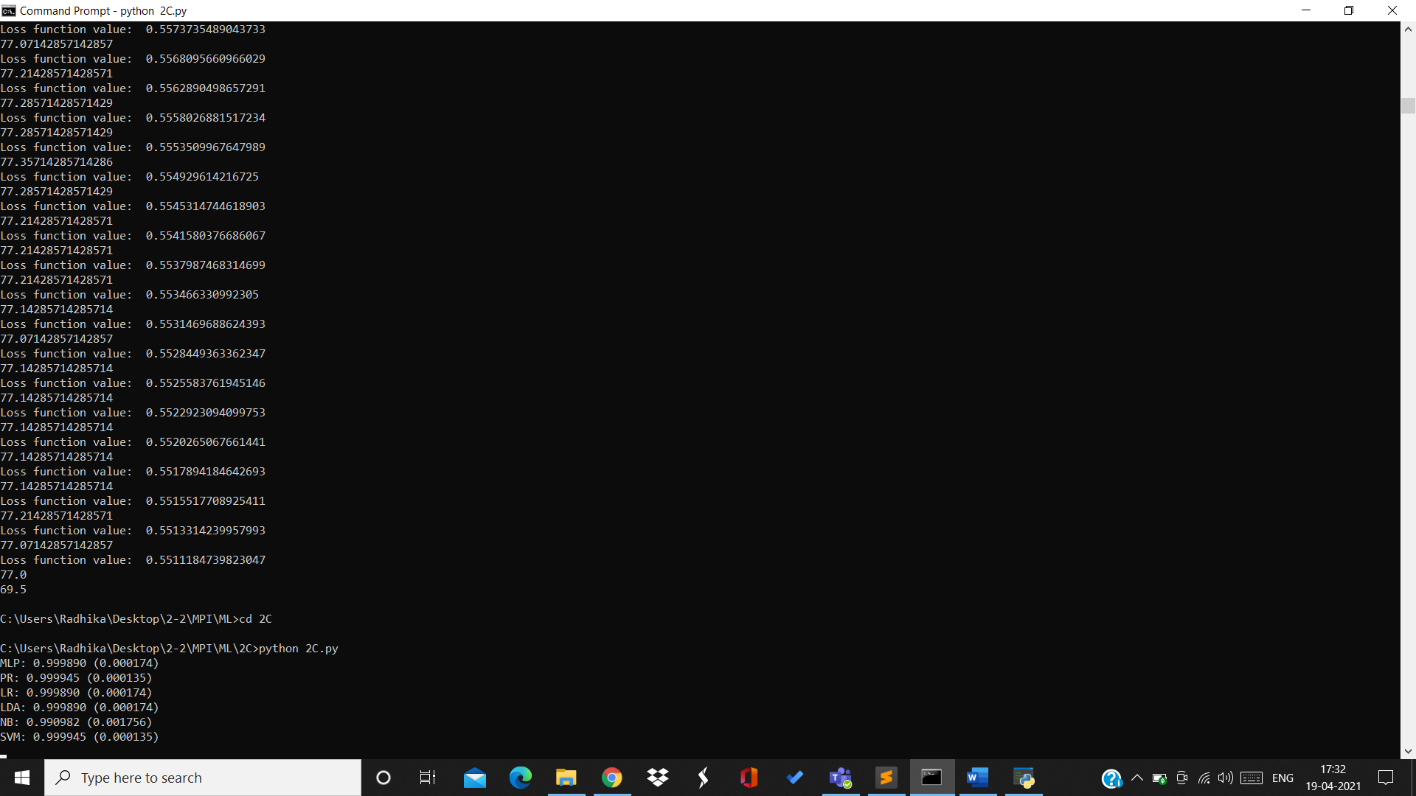

The model that performed best is Linear Perceptron because the data points were easily linearly separable.

The model that performed the worst is Naïve Bayes because the attributes are linked to each other whereas Naïve Bayes model doesn’t account that.

Boxplot for comparison:

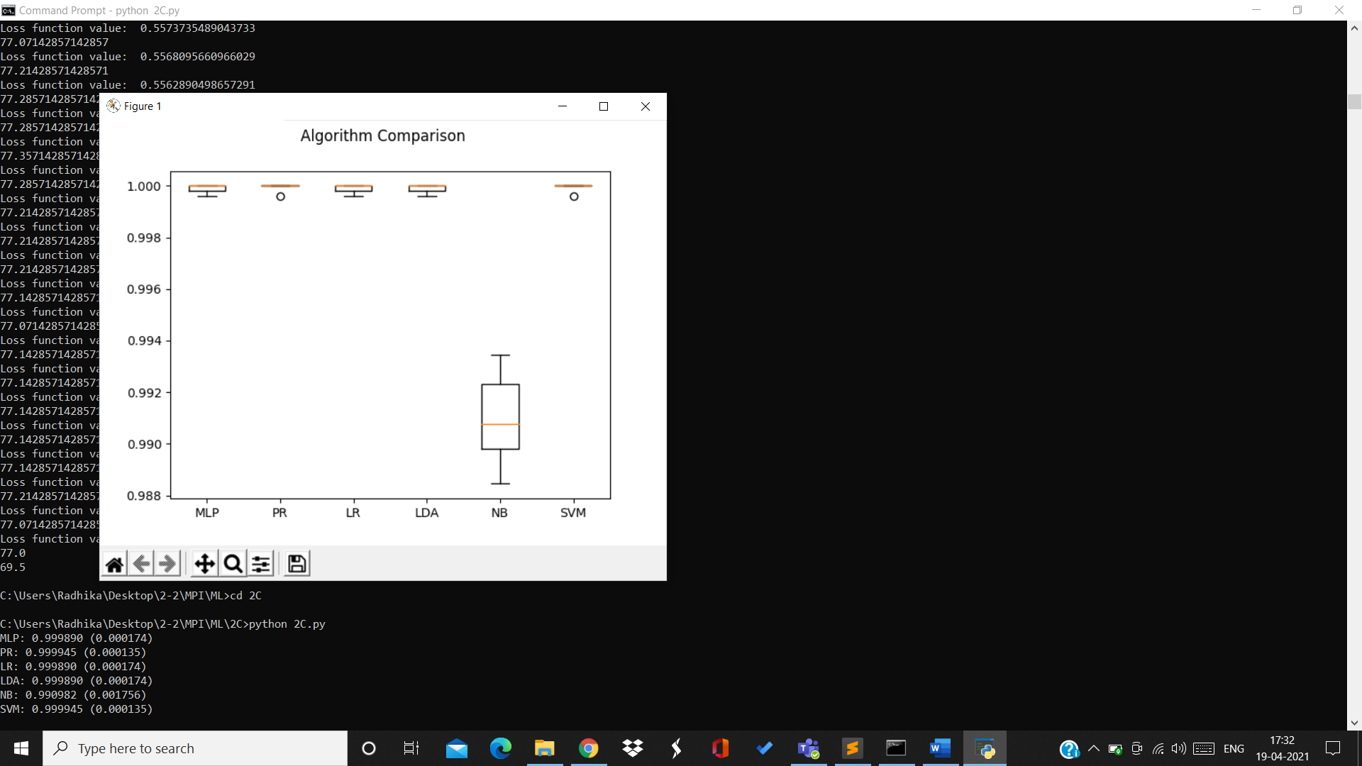

The heatmap shows the correlation between the attributes.

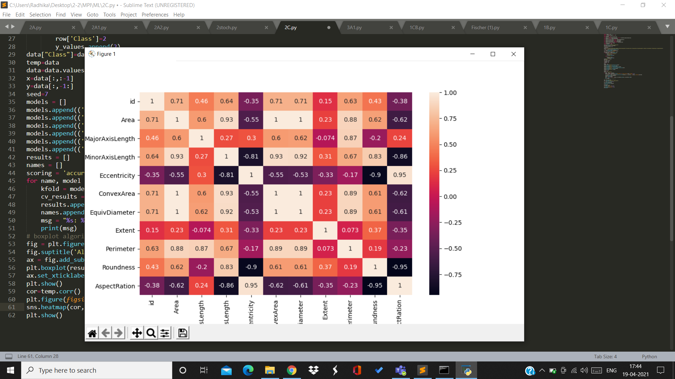

BY:

Radhika Sigtia 2019A7PS0094H

Bathini Akash 2019A7PS0065H

Sharvani Reddy 2019A7PS0050H